Southern Wesleyan University Homecoming Parade
October 31, 2015 11:45 a.m.
Join Southern Wesleyan University for Homecoming:
Fill the Hill 2015
We want your group or organization to participate with us in this celebration of spirit and creativity.
Fill out the attached form and submit it to the SWU Alumni Center, P.O. Box 1020, Central, SC 29630 by October 20th to reserve your spot in the parade.
Parade Route:
Parade begins lining up at 10:00 a.m. facing Thomas Lane on the lane beside Clayton Welcome Center that runs behind Newton Hobson Chapel and Nicholson-Mitchell Christian Ministry Center and attaches to Thomas Lane. Parade will commence at 11:45 a.m., turn right onto Thomas Lane, and immediately make another right onto Wesleyan Drive. The parade will pause when passing through the grandstand area where our announcers will read your pre-written description of your entry. The parade will continue down Wesleyan Drive, turning right onto Clayton Street, turning right on the lane to end the parade back where it began, completing the loop.
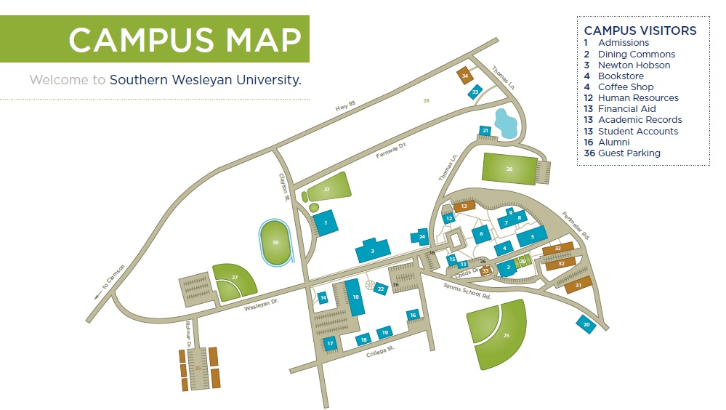

End
Begin

Southern Wesleyan University Homecoming Parade
October 31, 2015 11:45 a.m.
REGISTRATION DEADLINE: October 23, 2015
Community Participant Registration Form:
Group Name: ______________________________________________
Main Contact Name: _______________________________________________
Main Contact Phone Number: _______________________________________
Main Contact E-Mail Address:________________________________________
Briefly describe your entry in the parade:
____________________________________________________________________________________________________________________________________________________________________________________________________________________________________________________________________________________________________________________________________________________
Share some comments you would like announced as your group passes the grandstand:
____________________________________________________________________________________________________________________________________________________________________________________________________________________________________________________________________________________________________________________________________________________
I want my entry to be judged in the Founders Cup Trophy Contest (SWU Campus Community Only. Please visit www.swu.edu/homecoming for Trophy Contest rules.)
Rules and Regulations:
- Floats must be able to pass underneath power lines on Wesleyan Drive
- Floats must not include content or display messages deemed inappropriate according to Southern Wesleyan University policy
- Floats must obey local, state, and federal laws regarding noise, pollution, litter, etc.
NO REGISTRATION FEE NECESSARY. REGISTRATION FORMS MUST BE RECEIVED BY THE ALUMNI OFFICE NO LATER THAN OCTOBER 23RD

Please Mail to:
SWU Alumni Office
PO Box 1020
Central, SC 29630

Have questions? Call Ethan Cashwell (864) 644-5383

